# Table of Contents

**Network-as-a-Service Runbook**

***MOP MW Equipment Installation Template***

**<NaaS Operator’s Name>**

**

*<Release Date>*

Table of Contents 1

1 Document Control 3

2 About Design Template 4

2.1 Document Purpose 4

3 Access Request 5

4 Health & Safety Measures 5

5 Pre-Installation 6

5.1 Site Material Received 6

5.2 Details of tools and testers 7

5.3 Verify Weather Conditions 8

5.4 Winch Installation 8

6 Connection Diagram 8

7 Equipment Description 8

8 IDU Installation 9

9 ODU Installation 10

9.1 Locate ODU position 10

9.2 ODU Lifting. 11

9.3 Installing the ODU on a Pole 12

10 Cable Installation 16

10.1 Installing Grounding Cables 16

10.2 Installing Power Cables 16

10.3 Installing Signal Cable 17

10.4 Installing the Opting Fiber 17

10.5 Intermediate Frequency Cable 18

11 Antenna Adjustment 18

12 Commissioning 22

13 Labeling 26

14 Annex A 26

# Document Control

- Revision Control sheet allows to maintain a record of changes made on the document.

|  |  |  |  |
| --- | --- | --- | --- |
| Version N° | Issue Date | Status | Reasons for Change |
|  |  |  |  |
|  |  |  |  |
|  |  |  |  |
|  |  |  |  |

Table 1. Revision History

# About Design Template

## Document Purpose

The purpose of this document is provide guidelines and a sample of a Installation Method of Procedure of a Microwave backhaul equipment of any kind.

# Access Request

* The Access Request Form must include the following:
* Name, Position and ID of the Tower Access Seeker proposing to access the Tower,
* Details of the company for which the Tower Access Seeker works,
* Site on which the Tower is located,
* Proposed date(s) and time(s) of access and proposed duration of the works,
* Purpose of the access,
* Equipment that will be required for the works,
* Scope of Works (SOW),
* Method of Procedure (MOP),
* Safe Work Method Statement (SWMS),
* License or certification for the operation of any major equipment to be used , for example using an elevated work platform (EWP), scissor lift or cherry picker, Copy of Climbing
* Certificates / licences (riggers),
* Copy of Tower Rescue Certificates (riggers),
* Copy of Medical Certificates,
* Copy of First Aid certificates,
* Any other information required by applicable work health and safety laws and regulations for applicable jurisdictions (for example in NSW the Work Health and Safety Act 2011 (NSW) and Work Health and Safety Regulations according to local regulations (NSW)).

***Insert the Naas Operator Access Procedures***

# Health & Safety Measures

* Before any person shall commence a tower climb, they must:
* Familiarize themselves with the risks at the Site and on the Tower and understand the risks
* Inherent in working in an RF environment and be aware of the “go/no go” designated areas.
* Be fully conversant with the operation of all safety equipment and techniques; and
* Take into consideration current and predicted weather conditions and take the requisite
* Precautions to prevent exposure and potential slip hazards.
* During the climb each person must:
* Limit their work on the Tower solely to the area and work approved on the Tower Access
* Request Form and within daylight hours on a Monday to Friday basis,
* carry a means of portable communications,
* Verify the presence of fire extinguisher and first aid Kit

All NaaS Operator Field Workers that will work in tower site must wear their PPE this requisite is mandatory :

|  |  |  |
| --- | --- | --- |
| Panoramic eye protectors |  |  |
| Helmet with chinstrap for work at height |  |  |
| Dielectric safety footwear |  |  |
| High abrasion gloves |  | Abrasion Resistant Work Gloves | Aviation Spares & Repairs |
| Dielectric gloves |  |  |
| Full body safety harness |  |  |
| Double lashing strap (monkey tail) |  |  |
| Suspension strap |  |  |
| Positioning belt |  |  |
| Life rope |  |  |
| Save sliding falls (lifeline) |  | Miller Guide - Smart Policy Safety Compliance at Height |
| Safety belt |  |  |

***Insert the Naas Operator Health and Safety Procedures***

# Pre-Installation

## Site Material Received

|  |  |  |  |
| --- | --- | --- | --- |
| **SI Code** | **Description** | **Serial** | **Comments** |
| MWQNT001 | MW Antenna | SN12334553 | NA |
| IDU001 | IDU Board | SN 234364 |  |
| IFCBLE | Base Band Sub rack | SN 56735 |  |
| PWCBLS | Power Cables | SN 234234 |  |
| GRNDGCB | Ground Cables | SN 234234 |  |
| ODU002 | Outdoor Unit | SN 234234 |  |
|  |  |  |  |

***Insert the Naas Operator Equipment and Material List***

## Details of tools and testers

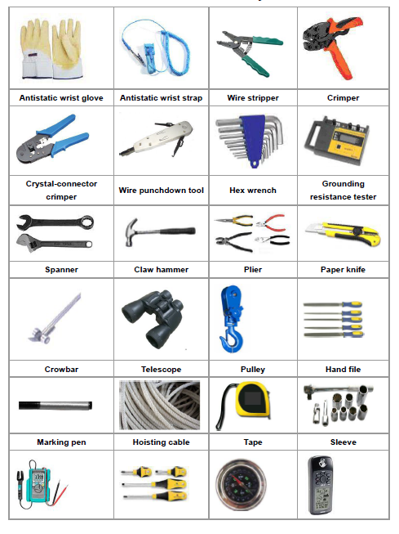

***Insert the Required Tools to perform the Installation***

## Verify Weather Conditions

Winds higher than 30 km / h, ice formation and/or snow accumulation, its required to suspend work at height, except critical areas, where works must have an authorization explicitly by engineering and must be informed the chief of operations before implementation.

## Winch Installation

The elevation of the components in height, both electronic and support, may be made with Winch with steel cable and brake. The winch will be fixed to the structure or anchors well secured.

# Connection Diagram

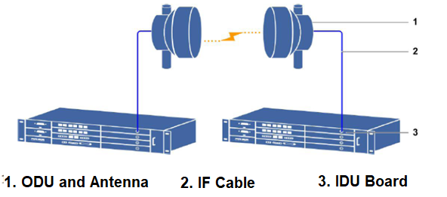

*Depending on the complexity of the scenario the connection Diagram could cover all connections in a single diagram or could be split, for example, Power Connections in one diagram fibers and RF connections in another diagram.*

# Equipment Description

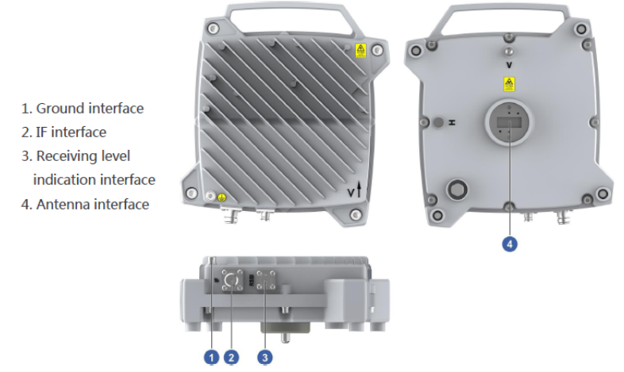 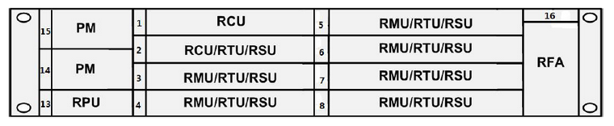

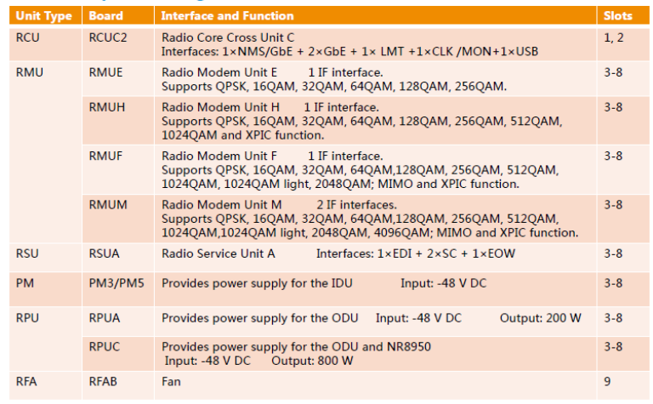

# IDU Installation

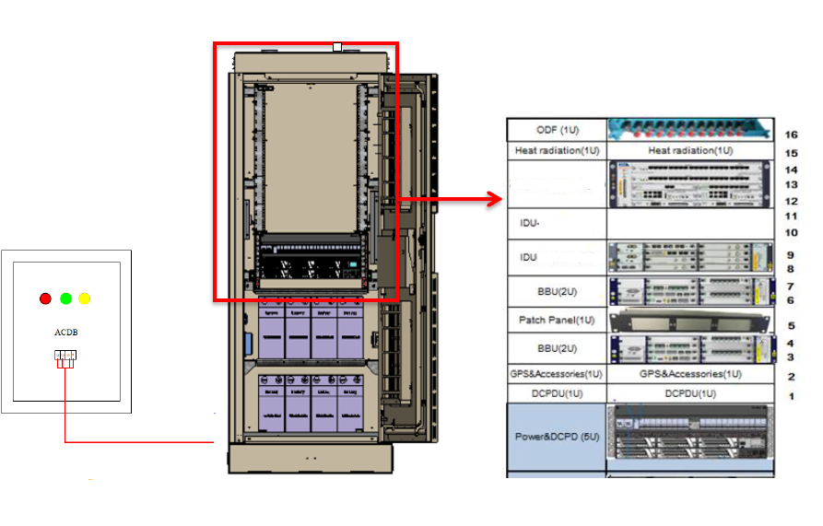

***Insert a Schematic Diagram that reflects where the IDU will be Installed***

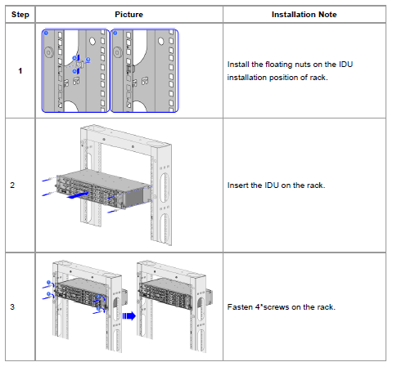

***Insert STEP BY STEP IDU Installation***

# ODU Installation

## Locate ODU position

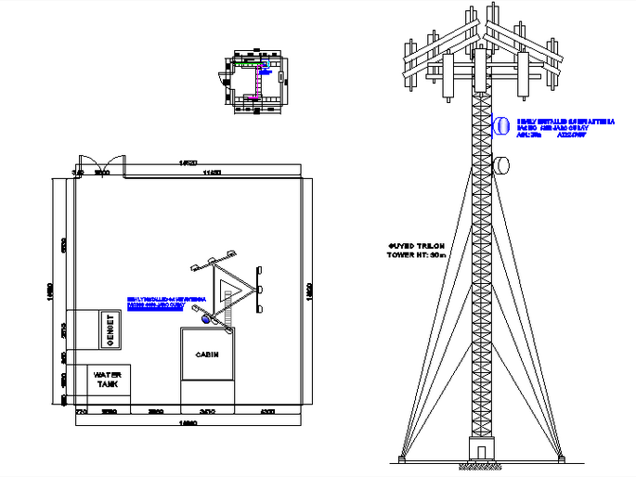

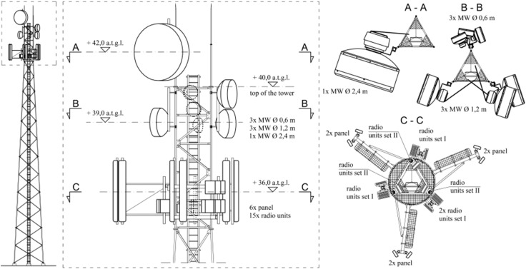

***Insert actual engineering diagrams where the MW ODU will be installed***

## ODU Lifting.

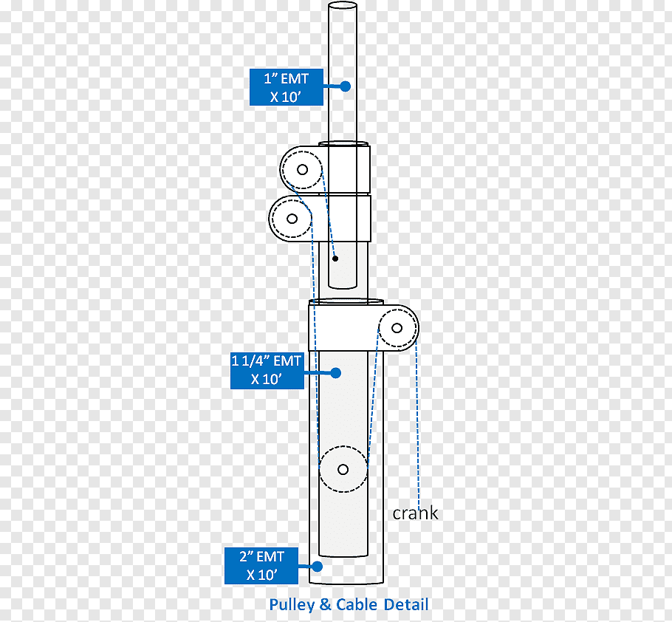

***Insert Step by Step instructions to Lift the ODU Unit***

## Installing the ODU on a Pole

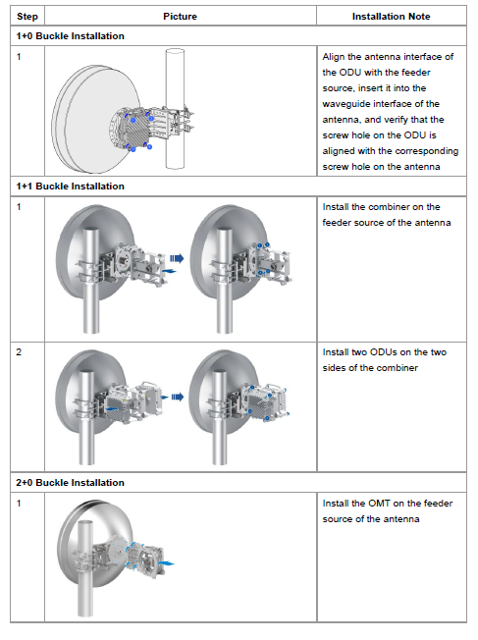

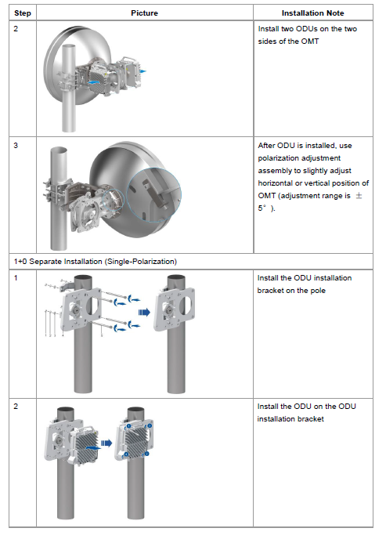

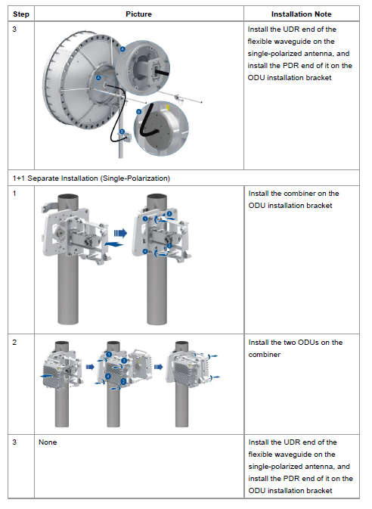

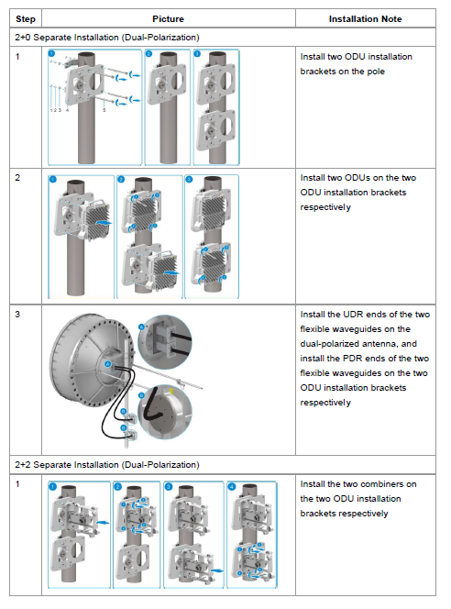

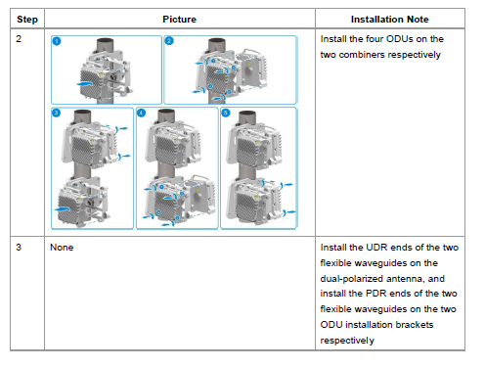

***Insert Step by Step instructions for mounting ODU***

# Cable Installation

## Installing Grounding Cables

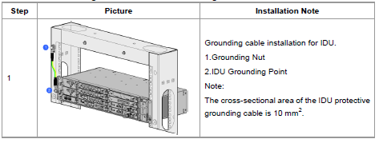

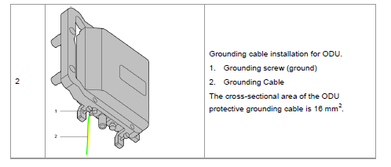

***Insert Step by Step Instructions to ground the equipment***

## Installing Power Cables

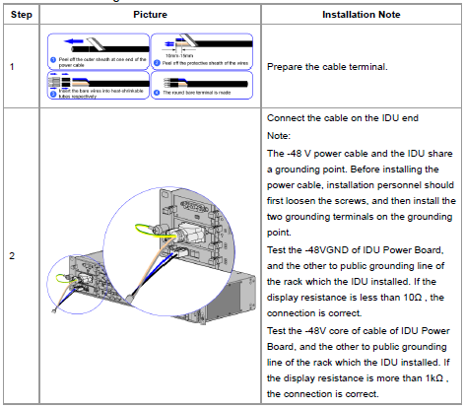

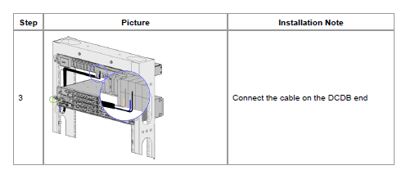

***Insert Step by Step instructions to connect Power Cables***

## Installing Signal Cable

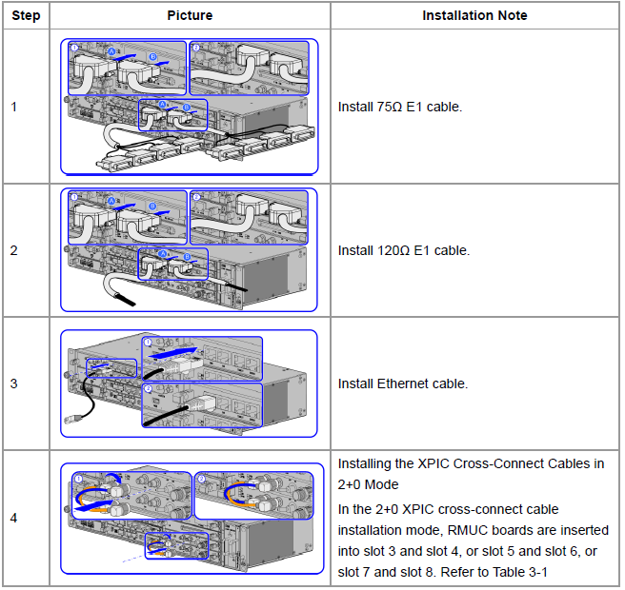

***Insert Step by step instructions to connect the Signal Cable***

## Installing the Opting Fiber

Define the arrangement of cable going down from radio units and the procedure:

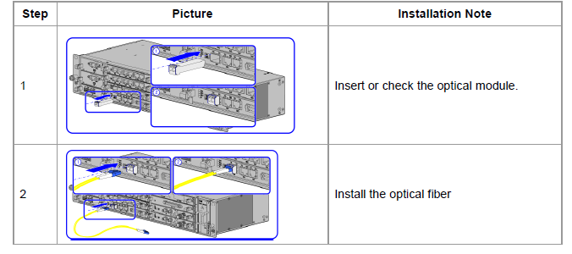

***Insert a Step by Step instructions to cable optic fiber***

## Intermediate Frequency Cable

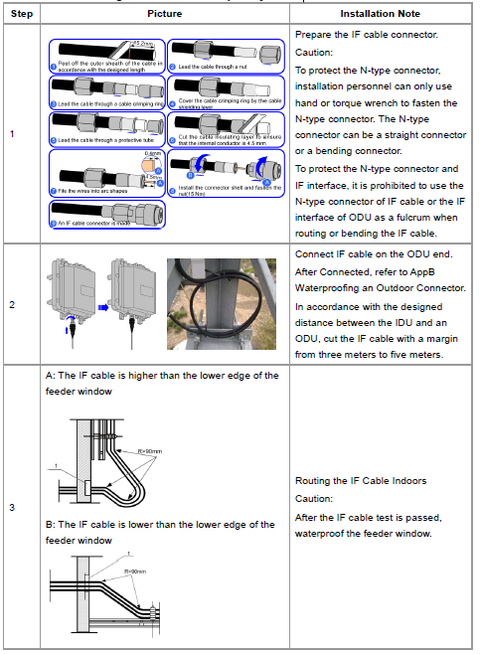

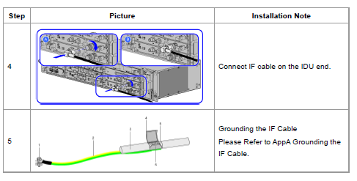

***Insert a Step by Step Procedure for installing IF Cable***

# Antenna Adjustment

|  |  |  |
| --- | --- | --- |
| **Step #** | **Picture** | **Note** |
| **Step 1** |  | If the distance between the two antennas is more than 2 km, place the two antennas horizontally. If the distance between the two antennas is no more than 2 km, slightly adjust the elevation of the antenna according to the actual situation. |
| **Step 2** |  | Connect the multimeter to the port of the local ODU correctly. Then, measure the VBNC of the RSSI port. |
| **Step 3** |  | **Adjust the azimuth of the antenna.** |
| **A.** Keep the opposite antenna fixed. **B.** Measure the VBNC by using the multimeter. Move the antenna from left to right and make sure that the antenna tracks at least three peak signals of the VBNC. The voltage of the second peak signal should be the maximum one. |
|
| **Step 5** |  | **Adjust the elevation of the antenna.** |
| **A.** Adjust the elevation at each peak VBNC so that the VBNC can reach the maximum value.  **B.** Adjust the antenna to a position where the VBNC reaches the highest value. Then, fix the local antenna. Make sure that the VBNC is of the maximum value when the antenna is fixed. |
|
| **Step 6** |  | Repeat Steps 2 and 3 to adjust the antenna on the opposite side. After the RSL of the opposite antenna reaches the maximum value, fix the opposite antenna. |
| **Step 7** |  | Repeat Steps 2–4 two to four times to make the receive signal levels at both ends reach the maximum value. Then, fix the antennas at both ends. |
| **Step 8** |  | Measure the VBNC at both ends by using the multimeter. Obtain the current RSL by referring to the curve diagram and the RSL of the VBNC of the ODUs at both ends. |
| **Step 9** |  | Fasten all the screws of the antenna. |
| ***Insert a Step by Step Procedure to Adjust Antenna Azimuth Alignment according to Engineering Guidelines and vendor Specifications*** | | |

# Commissioning

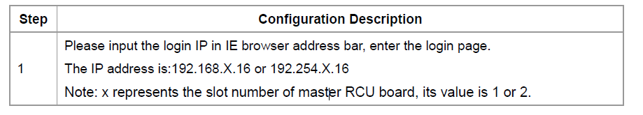

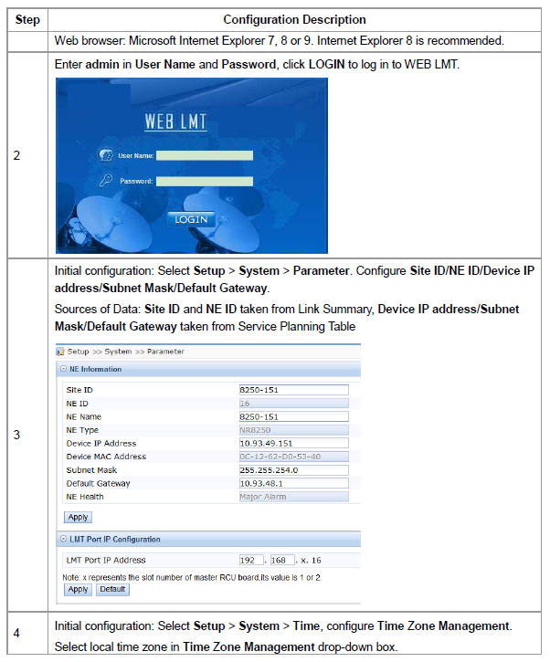

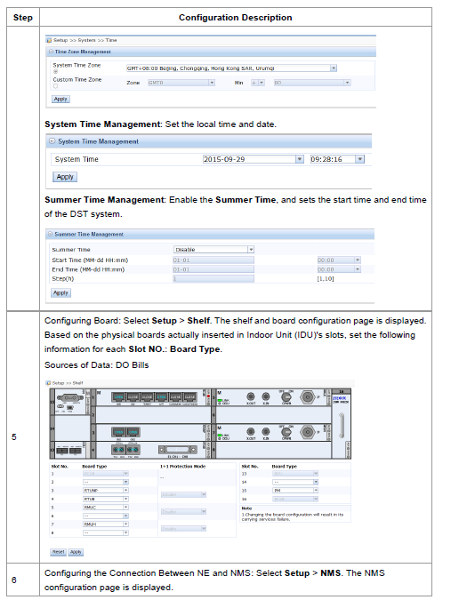

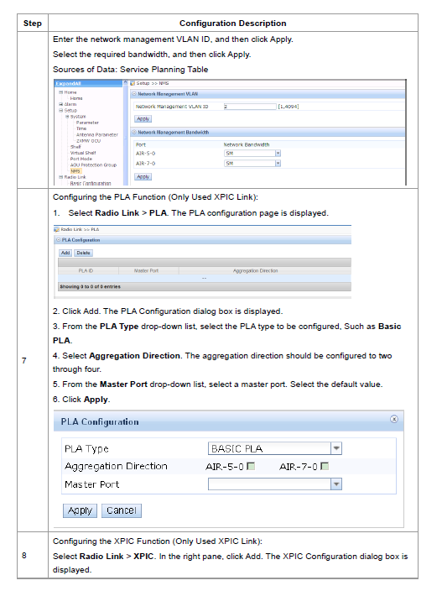

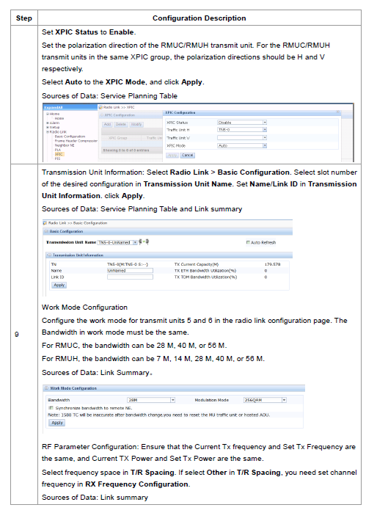

***Insert STEP by STEP Commissioning Guidelines customize instructions following NaaS Operator IP Plan***

# Labeling

# Annex A

Additional supporting information that should not be included in the document:

* Antenna Azimuth